

hub2

User Guide

TABLE OF CONTENTS

1. About 2

2. UI 3

3. Levels 6

4. Permissions 14

5. Handovers 20

6. Preservation 22

7. Imports & Exports 24

8. Glossary / Listing 26

# About

### Introduction

This user guide describes an introduction or reference guide for some of the more complex features of hub2; *qedi*’s next generation project management solution.

The document contains screen shots and information that were relevant at the time of release. As hub2 is a continuously developed product the actual appearance or function may differ from what is depicted.

In addition, some sections or operations shown may not be accessible due to permissions issues.

For the latest information on hub2 please visit <http://qedi-gotechnology.github.io> or contact [info@qedi.co.uk](mailto:info@qedi.co.uk)

### Intended Audience

It’s expected that readers will have completed the required training courses, and understand the fundamental concepts and basic operations, before reading this document.

This guide is intended for authorised users only and should not be distributed without the express consent of *qedi*.

### hub2

First released in October 2017, hub2 is the latest generation of qedi’s GoTechnology® family of online, web-accessible completions and commissioning management solutions.

Intended as a replacement for all previous products within the range, hub2 delivers the facilities to track, record and report on details of equipment, certification, handovers, procedures, preservation routines and Job Card information, amongst others.

#### Access

Details of how to access hub2 will be provided separately. Please note: As hub2 is a primarily online solution, an internet connection and a modern, HTML5 compliant web browser are required.

### Glossary of Terms / Listing of Information

At the end of this document is an abbreviated list of the information stored within hub2, where it can be viewed from, and which Level within the information hierarchy (described in 3 Levels below) it resides.

Important Note: This is not a complete listing, and is intended for basic reference purposes to the most commonly used areas of hub2. Client, industry or process specific information types will be excluded for this reason.

# UI

Let’s take a look at the User Interface (or UI) for hub2. This is the “look and feel” of the application: How information is displayed onscreen and how you interact with it.

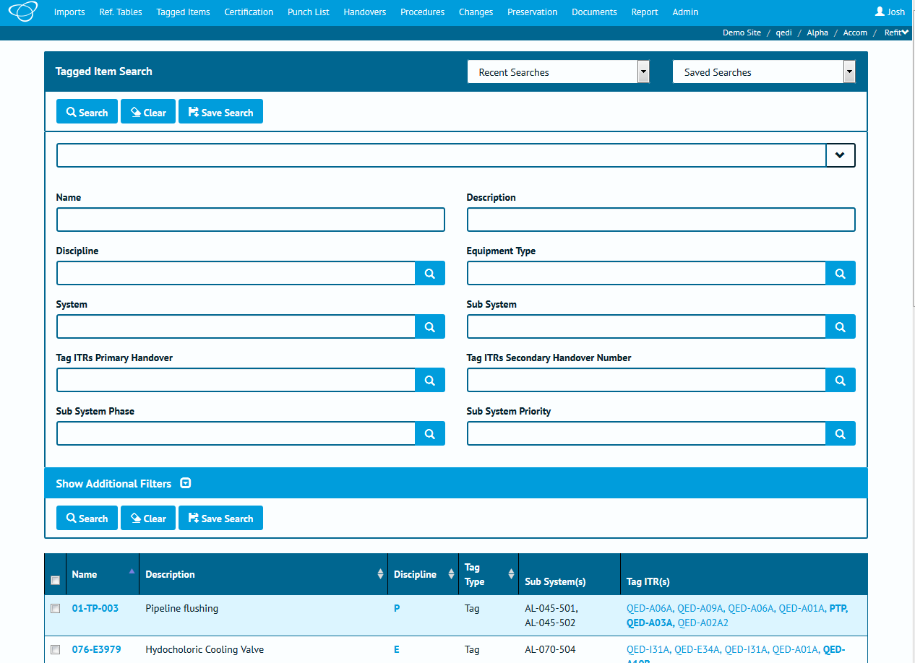

Depending on which version of hub2, your preferences, permissions and configuration, and the device your viewing on, some elements may appear differently, or not at all.

If we apply some highlighting to some different elements on this screen we can cover a lot of the basic concepts within hub2, which follow all the way through the application.

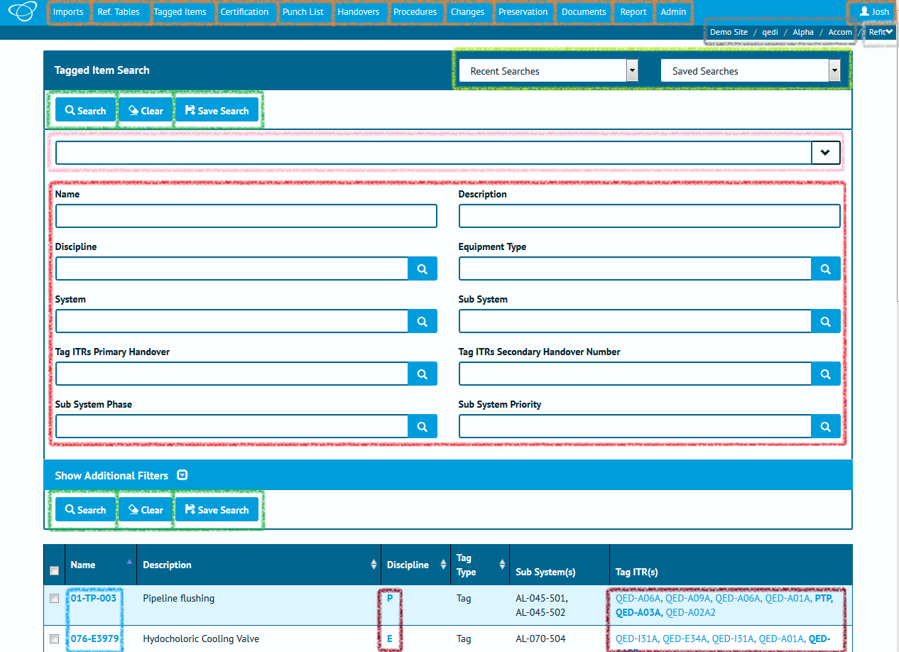

|  |  |  |  |
| --- | --- | --- | --- |
| Colour | Location | Element | Description |
| **◼** | Top of screen (menu bar) |  | The top menu buttons are the key to navigating hub2. Clicking one of these buttons will open a drop-down menu with links to specific pages.  This includes the button at the top right, which displays your name (or the name of whoever is currently logged in) and provides links to User preferences and options. |
| **◼** | Top Right |  | The navigation “breadcrumbs” show which Level A / Level B / Level C / Level D you’re currently logged in to. Click any of these elements will take you back to the Level select screen. |
| **◼** | Top Right |  | The final breadcrumb element represents the Level E. Clicking this will provide a drop-down of other Level E’s within this Level D, allowing you to quickly switch between them. |
| **◼** | Search Header |  | A drop-down menu that provides the five most recent searches you’ve run, allowing you to re-run them easily. |
|  | Lists any “Saved Searches” you have created via the “Save Search” button. |
| **◼** | Various locations, throughout hub2 |  | Buttons within hub2 have many purposes but are mainly used to trigger an action, whether it’s to start a search or import, add or delete an item, or, in the case of the button shown to the left, clear all the values from a form. |
| **◼** | Near the top of the search form |  | The quick search bar can be used to enter multiple search fields in one place.  In addition, the drop-down arrow, when clicked, provides a list of field definitions. |
| **◼** | Various locations,  throughout hub2 |  | Input fields can be used to enter search terms or add data.  This can be either typed directly, or in the case of dates, selected from a date picker. |
|  | For reference fields, the “lookup” button (represented by a magnifying glass) can be clicked to open a popup containing all the possible values that can be selected.  Alternatively, a value can be typed in directly as normal. |

# Levels

Within hub2 project information is stored in five connected levels. This might seem like a more complex approach than you’re used to before, but once we’ve explained it, you’ll understand how it’s easy to use, and will save time and improve consistency of data. Within the structure, inheritance is used: Information defined in the first level flows throw to the second, third, fourth and fifth levels, information in the second flows throws to the third, fourth and fifth level, and so on.

Within this document, we will refer to these levels as Level A, Level B, Level C, Level D and Level E, however they can be renamed by yourself or your hub2 administrator to use names that are much more relevant to your project or industry.

Here’s an example of how an instance of hub2 might be laid out. Don’t worry too much about the details at this stage, we’ll go into those later!

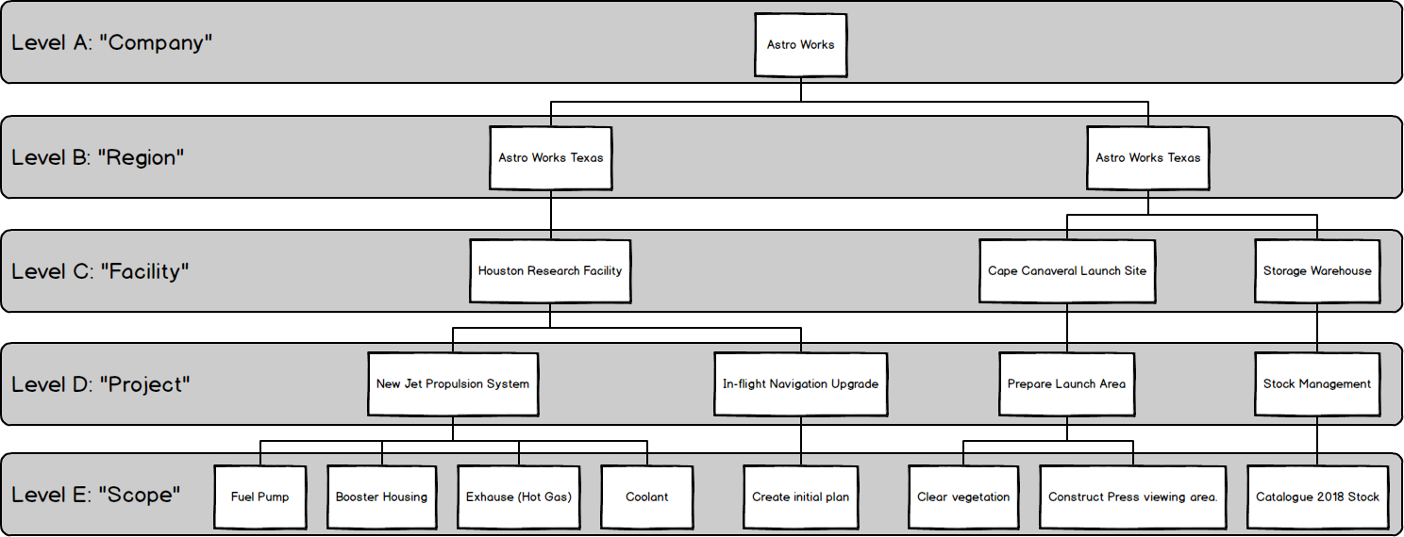

As you can see, in the above picture we have a fictional company named “Astro Works”, and a data structure that’s been designed in hub2 to best support their operations. This structure will allow the Astro Works teams to share the information they need, while making it clear who is working on what, and ensuring that any information is only available to the appropriate persons.

So how do we build up a structure like that, and what do these levels really represent? We’ll get into that in a second, but before we do, an important point.

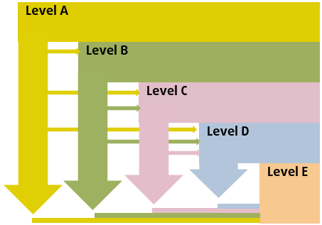

An Important Point about Levels

You (or your hub2 administrator) can change your Level configuration whenever you need to, so don’t worry about having to get it right first time.

If you’d like some advice on Level configuration, just get in touch. We’re here to help!

## Thinking about Levels

When it comes time to build up our data within hub2, we start at the “top” of the data hierarchy (Level A) and work our way down from there.

### Level A

As we know, Level A represents the “Company”, “Corporate” or “Global” level. It contains configuration options that will be utilised **in every part of the world, in every industry, on every project and work scope** the company does… Or at least that’s the idea! Of course, in reality this may not be practical, but we’ll discuss that later.

For now, let’s assume that there’s just one item in Level A representing the whole company. In our example case, that is Astro Works, our fictional space exploration organisation.

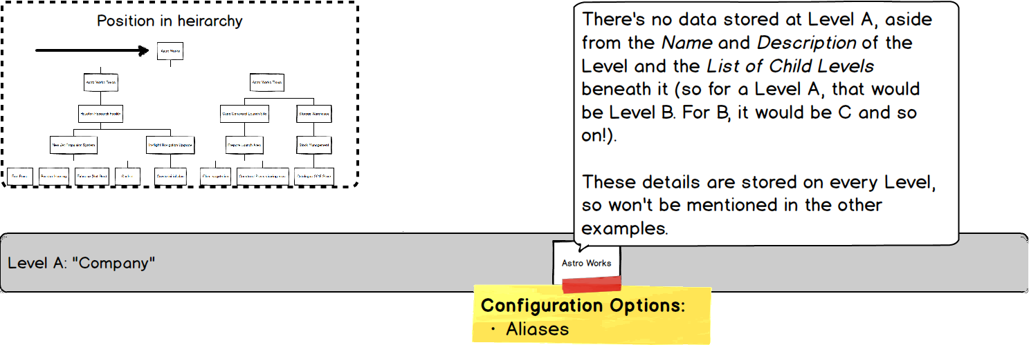

There’s no data stored at this level, but there are some options:

* Aliases

Aliases allow us to “rename” certain items on screen. As we’ve mentioned these can include the Levels themselves, as well as other items such as Certification Grouping. When we set an Alias for any field then the default name is replaced by the alias we’ve chosen.

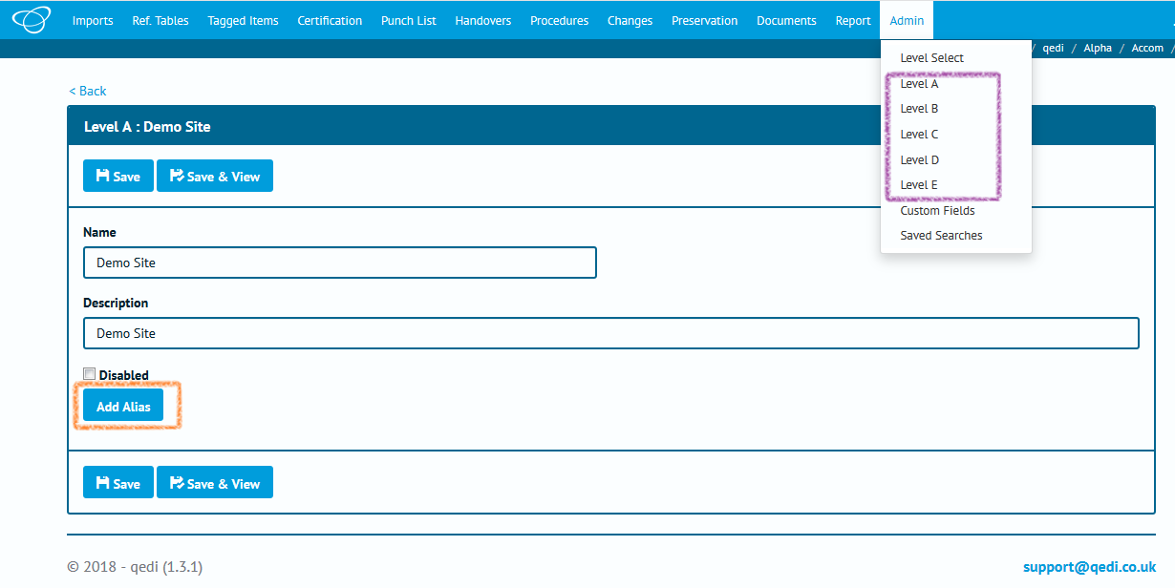

In the above screenshot, the orange highlight shows that there are no Alias at present, just the “Add Alias” button. The purple highlight shows that the default “Level A” to “Level E” are shown.

Let’s rename those to some more friendly values.

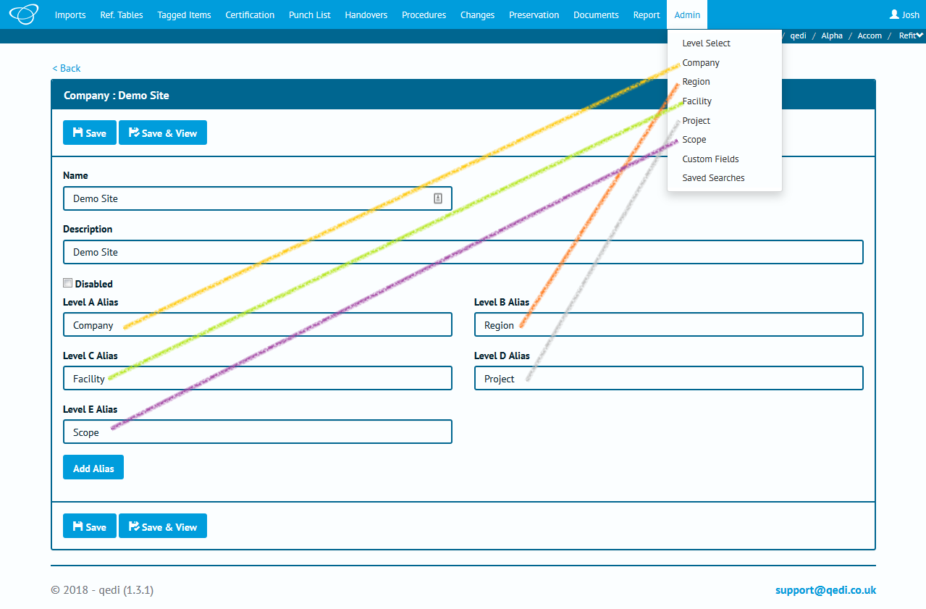

Once we save we can see the menu has updated too.

### Level B

Level B represents the first sub-division of the structure and is the first place we can actually store data. It’s usually used to represent a region, division or industry sector.

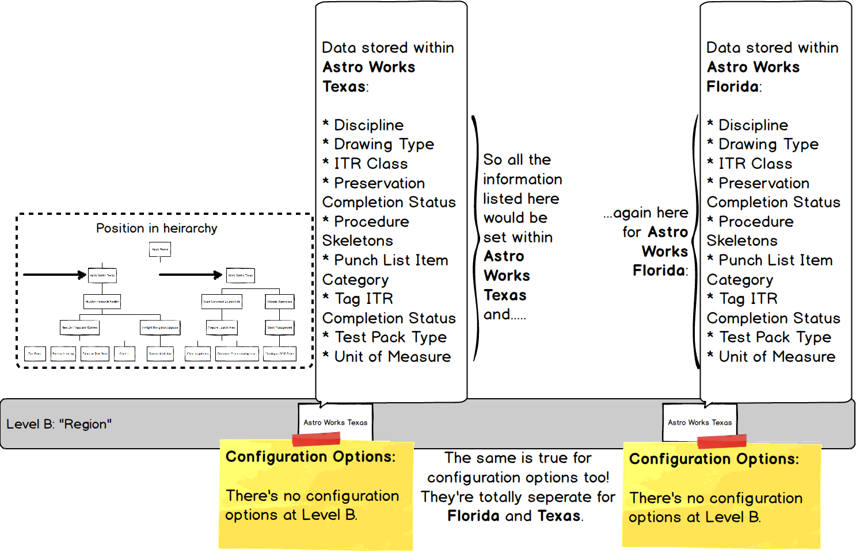

#### Information at Level B

The kind of information we store at this Level is very high level

Remember, any information set here will be used by the associated levels below:

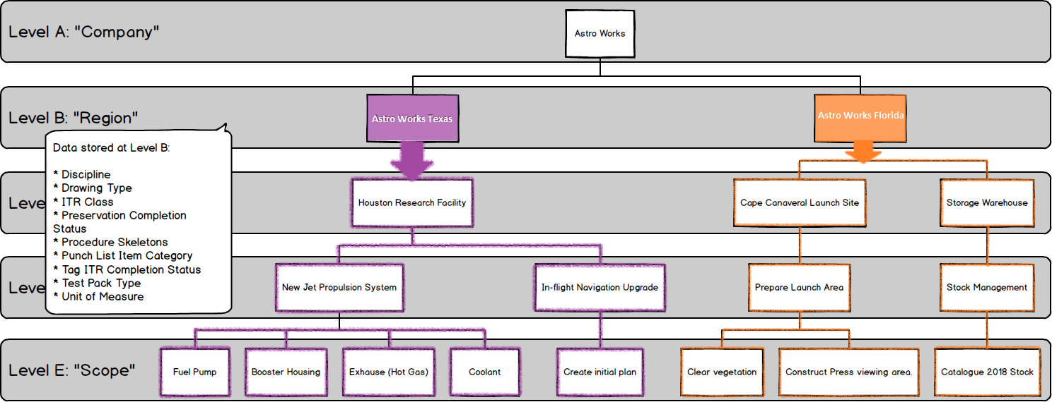

In the above picture we can see our two Level B’s (which we’re calling “Regions”) **Astro Works Texas** and **Astro Works Florida**, containing different information (which is shown by having one in purple and one in orange).

The solid colour indicates where the information is set, with the outlining showing where the information is used or referenced from.

As you would expect from our previous explanations, Levels below, reference the information defined in those above (by now we’re hoping this is becoming painfully obvious, and even repetitive, to you.

### Level C

Level C is usually used to represent a physical construction or geographic area in which multiple projects (which themselves have multiple scopes of work) are being (or will be) executed.

As such it contains a large amount of data, as well as a few key configuration options:

* Preservation Progress Method
* Preservation Window Before
* Preservation Window After

These are described in more detail, and in context, in 6 Preservation.

Let’s go back to our diagram and take a look at Level C in more detail

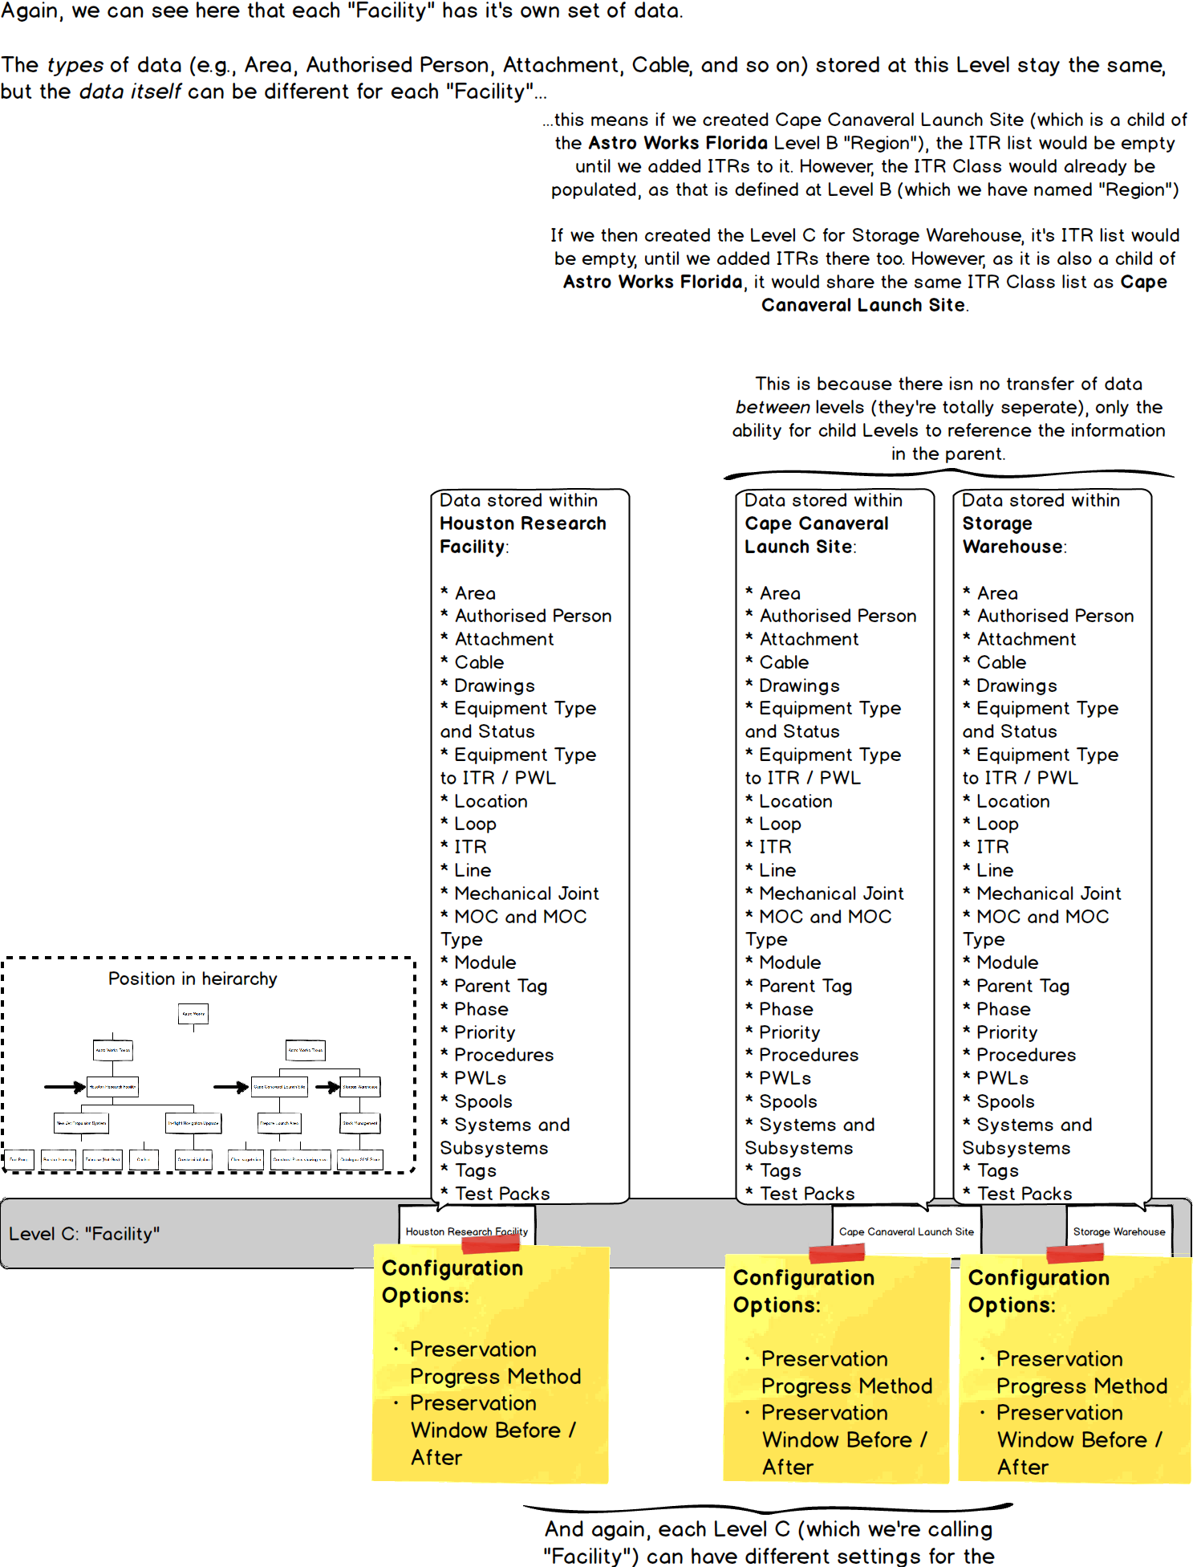

Just to repeat our previous point once more, the information set at Level C, will be utilised by the levels below:

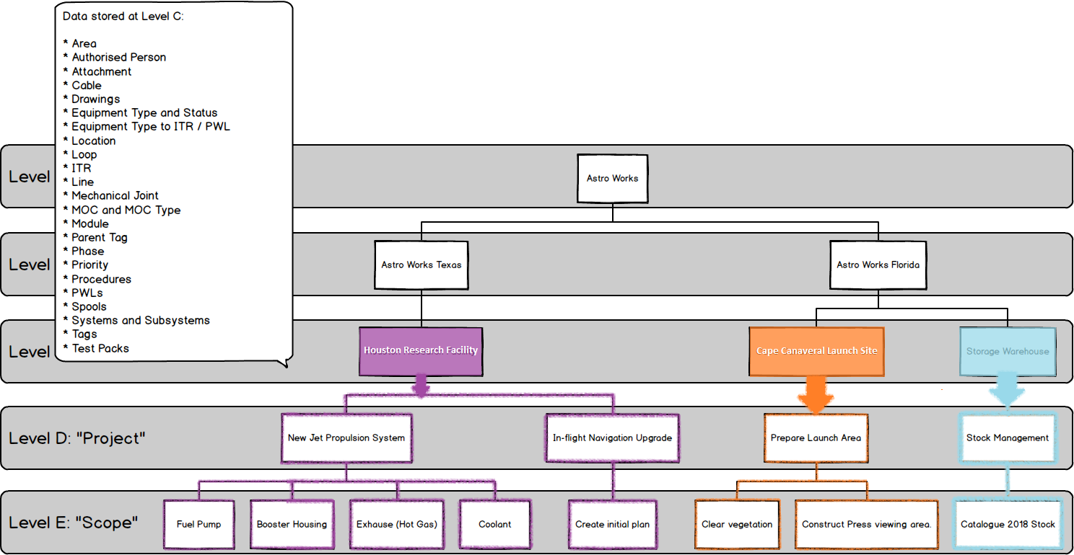

### Level D

Level D is the “Project” level, and represents a grouping of work scopes (which are recorded at Level E). As such, there’s not too much data stored here and, aside from the logos which appear on reports and certification, only one setting:

* Punch List Item Auto Number – Set whether Punch List numbers are generated automatically, and any conventions/formats for that number.

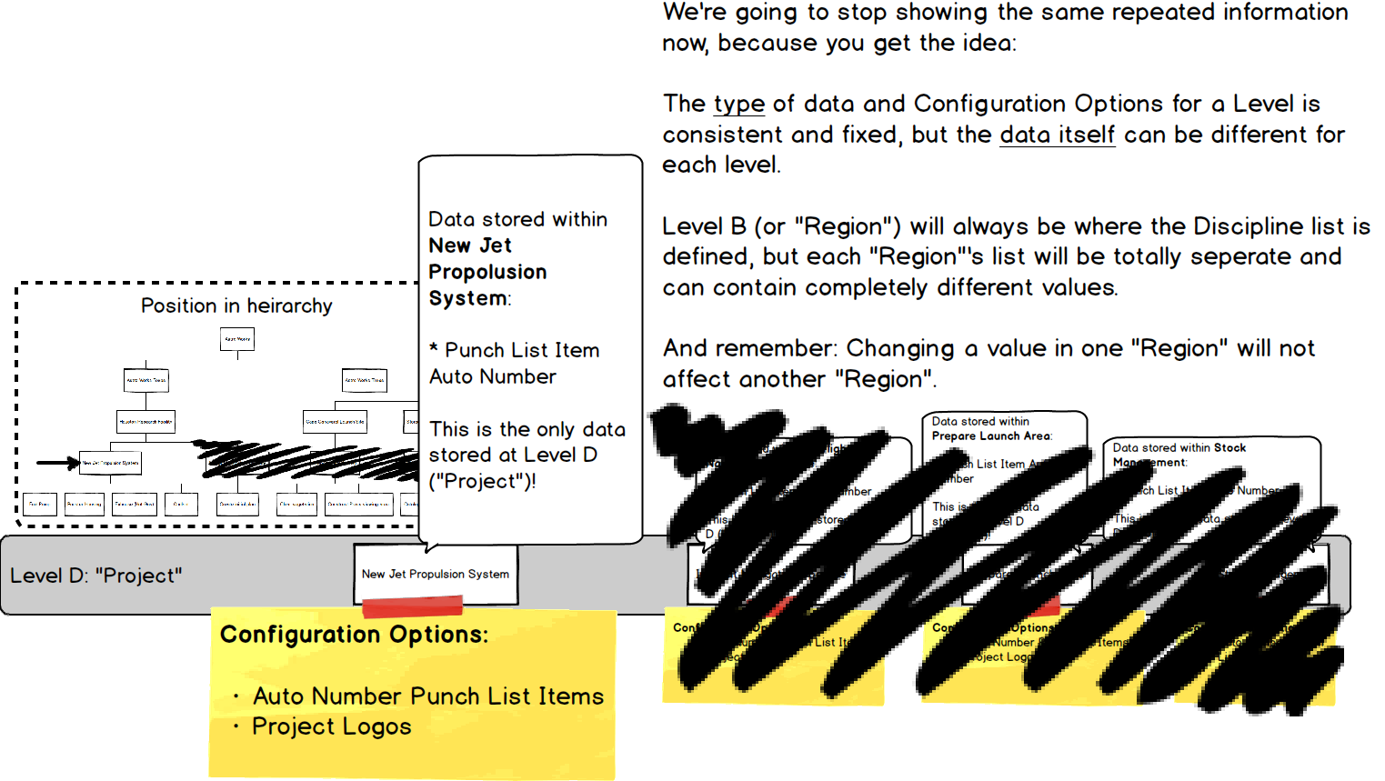

As we know, the information at a higher Level is referenced by those beneath it. This time we’ll show the structure without highlighting. Can you imagine which Level E’s inherit from where?

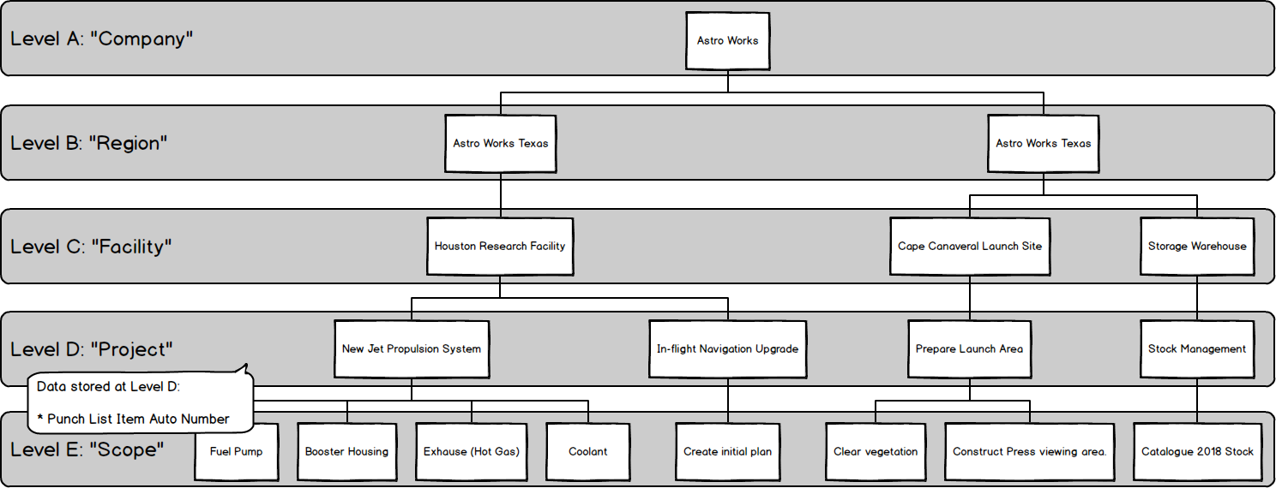

We’re sure you figured it out – it’s just a case of tracing the lines.

### Level E

Level E represents the scope of work – it’s where sign-offs are stored and progress is recorded.

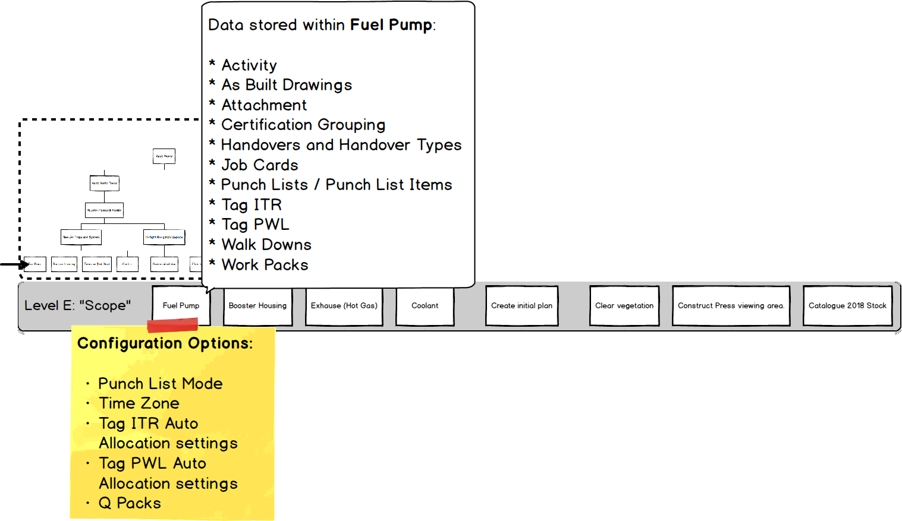

Level E is the lowest level, so any of our Level E’s (or “Scopes” as we’ve aliased them) won’t affect anything other than themselves.

# Permissions

Permissions within hub2 have a high level of flexibility: Authorisation can be fine-tuned for almost every table, to specify if a User can Add, Update, Delete or even see it at all. There are also additional special permissions for certain tables, such as the ability to sign-off Tag ITRs or Tag PWLs.

An Important Note about Permissions & Roles

Roles and Permissions can be changed as needed and, for most users, you won’t need to know about them at all! For those who do need to know about it (because they’ll be performing Administrator functions) special training and guidance will be available.

So no need to worry! Just treat this as a little background about how hub2 works.

## Part 1: Roles

To make all these Permissions easier to manage, we have a couple of tools at our disposal. Firstly, permissions can be grouped together as a “Role”. Secondly, we can choose which Level we “Assign” a Role or Permission too – this is because the abilities of a Role are limited/linked to the Level it’s assigned to and it’s “children” (for example, Tags are managed at Level C. If we assign a role for creating tags, but only on a Level D or a Level E, then the User won’t be able to do anything.)

We’ll talk more about that later though. Let’s start off by looking at Roles.

The standard roles within hub2 are as follows (correct at time of writing):

|  |  |
| --- | --- |
| Role | Permissions Included |
| Tag Full Permissions | Tags, Test Packs, Lines, Spools, Cables and Mech Joints:   * Create (Add) * Read (View) * Update (Edit) * Delete * Import |
| Tag ITR Sign Off | Tag ITR:   * Sign Off |
| Tag ITR Full Permission | Tag ITR:   * Create (Add) * Read (View) * Update (Edit) * Delete * Import * Review (Access the “Equipment Type to ITR Review” page) * Full Tag ITR Digital Document permissions (fill in Tag ITRs onscreen, or via “Smart” PDFs) |
| Punch List Raise | Punch List, Punch List Item:   * Create (Add) |
| Punch List Sign Off | Punch List Item:   * Sign Off |
| MOC Sign Off | MOC:   * Sign Off |
| Scope User Sign Off | Handovers, Punch List Items, Tag ITR, and Tag PWL:   * Sign Off |
| Asset User Sign Off | Procedure, Procedure Section, Procedure Step and MOC:   * Sign Off |
| Handover Full Permission | Handovers:   * Create (Add) * Read (View) * Update (Edit) * Delete * Import * Sign Off |
| Level Administrator | Levels A, B, C, D and E:   * Create (Add) * Read (View) * Update (Edit) * Delete   Note: This allows the creation of the Levels themselves. So new “Regions”, “Assets”, “Projects”, etc can be created by this user. However, on its own it does not give them permission to perform any tasks (e.g. create Tags, sign-off Tag ITRs, etc) within any levels. |
| Full Write Access | This is the opposite of the Level Administrator in that it grants full permissions to do everything (Create, Read, Update, Delete, Import, Sign Off, Review) except the actual creation of Levels themselves. |
| Importer | Import Access for all tables expect Level A to E |
| Scope Importer | Tag ITR, Punch Lists, Punch List Items, Tag PWL, Procedure, Procedure Step, Procedure Section, Primary Handovers, Secondary Handovers and Handovers:   * Import |
| Template Admin | Handover Types, ITR, MOC Type and PWL:   * Upload (add/replace DOTX templates) |
| Base Access | Read Access to all tables |
| Asset User Sign Off | Procedure, Procedure Section, Procedure Step and MOC:   * Sign Off |
| Attachment Upload | Attachments:   * Create (Add) * Read (View) * Update (Edit) |

As you can see, some of the roles overlap. That’s ok – it won’t cause any problem if someone has the “same” permission twice.

In general, our advice is to go for the fewest amount of permissions possible, as it makes it much clearer who can do what.

## Part 2: Assignment

Now we have our Roles, but how do we choose which “Project” they apply to? And how do we make the whole process as flexible as possible, while still making it quick and easy to change?

The answer is through how we assign these roles, and in hub2 **any role** can be assigned at **any level**.

Let’s look at our Level Diagram again:



So, we can assign any of the roles listed in the table above, to any of the Levels in that diagram. We could assign it to any Level A, any Level B, any Level C, any Level D…. Well, let’s start off with something easy… Let’s assign permissions so that a User can create Punch List Items in any of the “Scopes” (Level E’s) in the Houston Research Facility (Level C).

### A simple example of assigning a role to multiple scopes.

First, we need to know what Role to choose. If we look back at the table we can see that “Punch List Raise” does exactly what we need, and nothing more. Sounds perfect!

Now, where to assign it? Well, we could assign it to each Level E itself:

* Fuel Pump
* Booster Housing
* Enclosure (Hot Gas)
* Coolant
* Create Initial Plan

But there’s an easier way! You might be able to guess as to what it is (keeping in mind what we know about how Levels work, and that we can assign permissions at any Level), but if not, here it is:

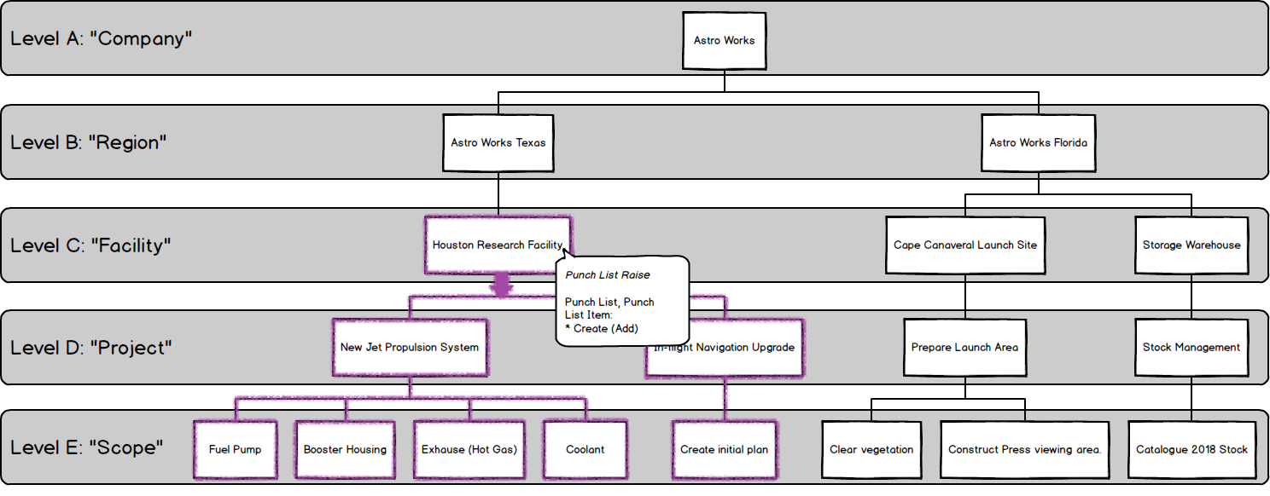

By assigning the Permission to “Houston Research Facility” then the permission applies to all levels beneath.

This also means that if a new Level E is added, then the User with this role will automatically have permission to Create Punch Lists and Punch List Items there too.

If, on the other hand, we only wanted to assign to specific Level E’s (let’s say all of those in “Houston Research Facility” **except** “Coolant”)

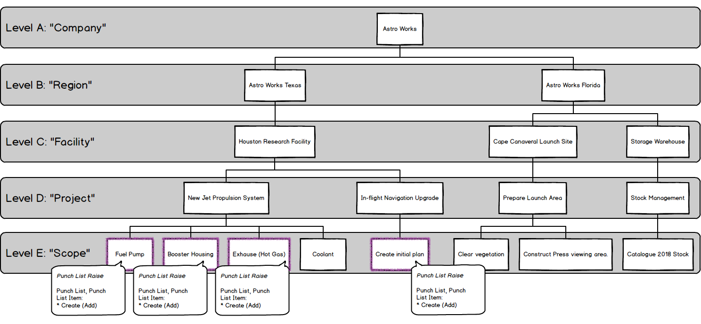

As we can see, there’s no one “right” way to do things. We can accomplish the same outcome in several ways, mixing and matching Roles and Levels to get the right result.

Let’s look at another, more complex example.

### Achieving the same result in different ways

Depending on what Role we choose and what Level we assign it, we can achieve the same result in different ways.

Understanding this can help us grasp how the Permissions system works.

Let’s imagine an example where we want to give a User permission to **import** to all Level E’s within “Houston Research Facility”, but **only the items stored at Level E (**Tag ITR, Punch Lists, Punch List Items, Tag PWL, Procedure, Procedure Step, Procedure Section, Primary Handovers, Secondary Handovers and Handovers)**.**

Well, let’s look back at what Roles are available for Importing…

|  |  |
| --- | --- |
| Role | Permissions Included |
| Importer | Import permissions for all tables expect Level A to E |
| Scope Importer | Tag ITR, Punch Lists, Punch List Items, Tag PWL, Procedure, Procedure Step, Procedure Section, Primary Handovers, Secondary Handovers and Handovers:   * Import |

The first option (Importer) looks like it might be overkill for what we need, as we only want to import the tables which are at Level E. However, the second option (Scope Importer) matches perfectly. If we assign that to “Houston Research Facility”, we get exactly the result we want.

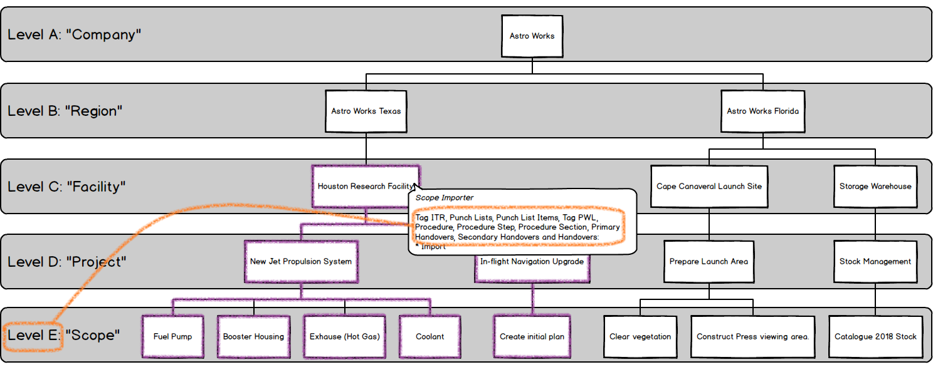

Perfect!

But could we achieve the **same** result with the other Role as well? As it happens we can:

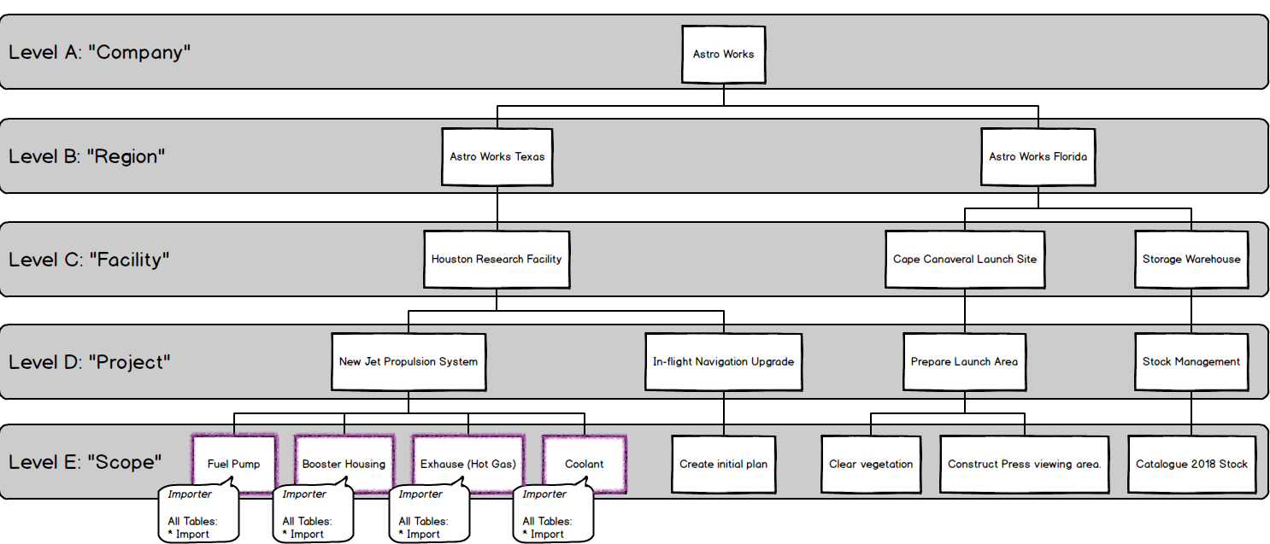

How does this work? Well, even though the “Importer” role specified access to import **all** tables, what it really should say is “Provides import permission to tables belonging to the Level it is assigned to and to the tables belonging to any child levels, except for the tables representing the Levels themselves.” But that’s a bit wordy!

So, by assigning a powerful permission at a low level, we limit its power. As with data, permissions flow downwards. By assigning the ability to use any import, but allocating it to a Level E, what we actually get is that any Import within that Level E can be used. So, assigning it to those four Level E’s gives us what we want in a different way.

# Handovers

Handover Certificates, usually referred to simply as ‘Handovers’ are used to guarantee Technical Integrity when responsibility is being transferred between Authorities.

Exactly what is being handed over, and when, varies between company, project and geographic location. Because of this, GoTechnology® applications have a flexible approach, with a variety of configurations which can be used on a “per-project” basis (Level D within hub2) allowing each to have its own Handover configuration.

The key components in each Handover are:

1. Name
2. Grouping
3. Gating

While the name is self-explanatory, the Grouping and Gating require further explanation.

### Grouping

The Handover Grouping controls the “what” of the Handover, as in “What is it that I am handing over?” Perhaps the most commonly used Handover Groupings are System and Subsystem (e.g. when a Subsystem Handover is completed it represents a statement that responsibility for that Subsystem can be transferred onwards) but there are other categories too. The following groupings are available in hub2

1. Certification Grouping
2. System
3. Subsystem
4. Primary Handover
5. Secondary Handover
6. System / Discipline
7. Subsystem / Discipline
8. Area
9. Module
10. Level E

### Gating

The Handover Gating determines the “which” (the ‘scope’) and “when” (the ‘ordering’) of the Handover within the overall project, serving to answer the questions “Which certificates/ITRs are covered by this Handover and when in the complete Handover process should this particular Handover occur?”

Both questions are answered with a single field: The Handover Gate Number.

This field acts as both a link between the Handover and the ITR Classes as well as means of ordering the Handover within the project.

#### Example: How Gating affects ordering.

As an example of how this works, consider a scenario where there are three Handovers (please note these are intended as examples only):

|  |  |
| --- | --- |
| Handover | Gating |
| HOC | 3 |
| MCDAC | 1 |
| PCDAC | 2 |

The Handovers are listed above alphabetically; however, in terms of the order within the Process, the MCDAC comes first, followed by the PCDAC and finally the HOC.

We can expand this further with an additional Handover:

|  |  |
| --- | --- |
| Handover | Gating |
| CCC | 1 |
| HOC | 3 |
| MCDAC | 1 |
| PCDAC | 2 |

Now we can see that both the CCC and the MCDAC are to be completed first, followed by the PCDAC and HOC.

#### Example: How Gating affects scoping.

If we retain our previous set of four Handovers and introduce a table listing our ITRs and ITR Classes we can see how Gating affects scoping too.

|  |  |
| --- | --- |
| ITR Class | Gating |
| COM | 3 |
| MC | 1 |
| PC | 2 |

Now we know that our CCC and MCDAC cover all ITRs in the MC ITR Class, our PCDAC covers all in the PC class and our CCC in the COM class.

### Walk Downs

Another key element in the handover process involves the physical inspection of the scope of the Handover (be it a System, Subsystem, Area or something else) by the process stakeholders. This process is known as a Walk Down.

There may be multiple Walk Downs held but all have the same general purpose: To identify any unrecorded defects and to verify that defects which have previously been identified have been actioned appropriately.

# Preservation

Preservation involves tasks related to ensuring unused equipment is kept in working condition. These tasks are often repeated on a regular schedule, to ensure the equipment is properly maintained and ready to use when required.

### Preservation Work List (PWL)

Within hub2 ‘Preservation Work Lists’ (PWLs) are used to record the completion of preservation tasks, and can be assigned to Tags, in a similar fashion to ITRs. The difference is that PWLs are part of a regular schedule of maintenance on unused equipment, while ITRs are used to sign-off that installed equipment is safe and has been properly tested as part of the Handover process (in which the goal is to start, or restart, the facility).

### Tag Preservation Work List (Tag PWL)

Just as a Tag ITR represents an actual assignment of an ITR to a Tag so does a Tag PWL represent a PWL to a Tag. To explain this further; our PWL table will contain an entry for each type of Work List available for use. So, if there are ten different Work List types (perhaps named ‘PRES-A’, ‘PRES-B’,’PRES-C’ and so on) then there will be ten entries in the PWL table.

However, any one of these PWLs may be assigned multiple times to many different tags. This is where the Tag PWL entity comes into play; storing the details of each Work List the user creates and assigns.

### Frequency

The Frequency of a Tag PWL describes how regularly the applicable preservation work should be performed. If a Tag PWL has a Frequency of seven days, then it should be performed once every week.

If it has a Frequency of 365 days it should be performed once, and then is not due for another 365 days, either from the Due Date (so the schedule remains consistent) or from the Sign-Off Date (so the schedule adjusts based on when the Tag PWL was actually signed off), depending on the configuration of hub2.

### Due Date and Sign-Off Date

The Due Date is when the Tag PWL is expected to be completed by, while the Sign-Off Date is when the Tag PWL was actually signed off. It is possible in hub2 to apply restrictions to when Sign-Off can be accomplished, via the Level C Preservation Window Before and Preservation Window After settings.

### Preservation Window

The Preservation Window (via the Preservation Window Before and Preservation Window After fields on Level C) allows restrictions to be placed on when a Tag PWL can be signed-off, specifically in relation to the Due Date.

The settings allow the Preservation Window to be restrict how many days before and how many days after the Due Date is acceptable. These values can be different. If either (or both) value is left blank, then no restriction applies.

#### Examples

##### Due Date: 14 February 2017

|  |  |  |  |
| --- | --- | --- | --- |
| Due Date | Preservation Window | | Acceptable Sign-Off Values |
| **Before** | **After** |
| 14 February 2017 |  |  | Any |
| 14 February 2017 |  | 2 | Any date **before** 17 February 2017. |
| 14 February 2017 | 2 | 2 | 12 February 2017 to 16 February 2017. |
| 14 February 2017 | 5 | 2 | 9 February 2017 to 16 February 2017. |

##### Due Date: 20 March 2049

|  |  |  |  |
| --- | --- | --- | --- |
| Due Date | Preservation Window | | Acceptable Sign-Off Values |
| **Before** | **After** |
| 20 March 2049 |  |  | Any |
| 20 March 2049 |  | 2 | Any date **before** 19 March 2049. |
| 20 March 2049 | 3 | 4 | 17 March 2049 to 24 March 2049 |
| 20 March 2049 | 31 | 16 | 17 February 2049 to 5 April 2049 |

### Preservation Progress Method

Preservation Progress Method is a Level C setting which will be used to determine the next Due Date when advancing Preservation which is being signed off. When any Tag PWL item which has a populated Frequency, field is signed off a new Tag PWL record will be created and its Due Date will be set based on the Preservation Progress Method as detailed in the following table:

|  |  |  |  |
| --- | --- | --- | --- |
| Preservation Progress Method | Due Date | Sign Off Date | Advanced Due Date (Frequency of 5 Days) |
| Due Date | 15/01/2016 | 18/01/2016 | 20/01/2016 |
| Sign Off Date | 15/01/2016 | 18/01/2016 | 23/01/2016 |

# Imports & Exports

## Import Ordering

### List

1. Primary Handover (if applicable)
2. Secondary Handover (if applicable)
3. Location
4. Module
5. Area
6. Priority
7. System Group
8. System
9. Subsystem
10. Loop
11. Activity
12. Authorised Person
13. Unit of Measure
14. Test Pack Type
15. Discipline
16. DrawingType
17. Drawings
18. Certification Grouping
19. ITR Class
20. ITR
21. Q Pack (if applicable)
22. Equipment Status
23. Equipment Type
24. Equipment Type to ITR
25. Parent Tag
26. Tag ITR Completion Status
27. Tagged Item
28. Tag
29. Tag ITR
30. Tag Q-Pack
31. Tag Subsystem
32. Test Pack
33. Work Pack
34. Procedure
35. Procedure System
36. Procedure Section
37. Procedure Skeleton
38. Procedure Skeleton Section
39. Procedure Skeleton Step
40. Procedure Step
41. Punch List Item Category
42. Punch List
43. Punch List Item
44. Job Card
45. Handovers (multiple)
46. Preservation Completion Status
47. PWL
48. Equipment Type to PWL
49. Tag PWL
50. Line
51. Spool
52. Mechanical Joint
53. Cable
54. MOC Type
55. MOC
56. MOC Discipline
57. MOC Primary Handover
58. MOC Secondary Handover
59. MOC System
60. MOC Subsystem
61. MOC Tag
62. MOC Work Pack

# Glossary / Listing

|  |  |  |  |
| --- | --- | --- | --- |
| Name | Description | Menu Location | Level |
| Activity | Activity within hub2 represents Level 3 in the recommended Work Breakdown Structure and as such exists as the “parent” of Job Cards and as a “child” of Level E.  The term “Activity” is often used interchangeably with Work Pack or Work Package, however hub2 treats them as separate but equivalent.  The Activity is intended to represent the Planning Component and as such represents a period of time utilised, rather than a physical document. | Reference Table | E |
| Area | Physical space, usually used in conjunction with Module representing part of a floor, an entire floor or even a whole building or structure, within a larger Asset or Facility. | Reference Table | C |
| As Built Drawings | As Built Drawings reflect what was constructed, rather than what was originally drawn; they are usually required when circumstances on site required a deviation and are issued when Construction is complete. | Documents | E |
| Attachment | An association between a file and a database entry. | Documents | C |
| Authorised Person | An entry in the Authorised Person reference table represents an individual who is authorised to perform certain activities on a work scope. Within hub2 Authorised Person is used to record information regarding the sign-off of a certification such as an ITR or PWL. Each one can be linked to a user in qedID through the Hub User ID field. | Reference Tables | C |
| Cable | In simple terms Cables are collections of one or more lengths of electrically conductive materials that are contained within protective and non-conductive coatings. The coatings are commonly known as ‘Sheaths’. Each conductive-material-and-Sheath combination is known as a Core.  It is possible that a cable may contain only a single Core, however it is more likely that it will comprise multiple Cores contained within an additional overall Sheath. | Tagged Items | C |
| Certification Grouping | A means by which a collection of ITRs can be associated by Discipline, Subsystem and Level E, the Certification Grouping is an aliased entity (meaning the labels shown on page can be renamed from “Certification Grouping” to something else) that can be used to fill the role of a ‘Discipline Mechanical Completion (DMC)’ field, while allowing project specific naming of that field. | Reference Tables | E |
| Discipline | Perhaps the easiest way to begin to describe a Discipline is to provide some examples of it: Electrical, Mechanical, Safety, Fire & Gas. These represent not only schools of knowledge to which an individual might specialize in, or assume responsibility for, but also categories of equipment or certification.  Within hub2 the Discipline will be recorded against items such as tagged equipment (Tags), Punch List Items and Inspection and Test Records (ITRs). This can then be used to filter and subdivide information, as well as to assign permissions and responsibilities to authorised individuals, with the full details of these functions being detailed in the relevant sections. | Reference Tables | B |
| Drawings | Drawings can cover a range of different types of illustration, including Isometrics, Process and Instrumentation Diagrams and General Arrangement Drawings amongst others. They serve to communicate information visually in a variety of ways, with the type of drawing used determined both by convention and what is most effective for serving the purpose required. | Reference Tables | C |
| Equipment Type & Status | Equipment Type provides a way of categorizing Tags based on the type of equipment. This can be useful in determining what type of ITR should be assigned, something that is covered in more detail in the Auto Allocation of Data section.  Equipment Status represents a further subdivision of this, and is an optional attribute to enable greater granularity. | Reference Tables | C |
| Equipment Type to ITR / PWL | Allows ITRs and PWLs to be automatically assigned to a Tag based on its Equipment Type. | Reference Tables | C |
| Handover | Handover Certificates, usually referred to simply as ‘Handovers’ are used to guarantee Technical Integrity when responsibility is being transferred between Authorities.  They’re explained in more detail in the Handovers section. | Handovers | E |
| ITR | Inspection and Test Records (ITRs) are records (traditionally paper-based checklists, but increasingly available digitally) used to certify that tagged equipment has been properly built and tested in line with agreed processes and procedures by approved and competent personnel.  The ITRs (also referred to as check sheets, tally sheets and certificates) include a list of tasks, measurements and activities that should be completed to verify the status of the equipment concerned.  While the design, content, naming and terminology of ITRs will vary between different companies, locations and projects their ultimate purpose is the same: To ensure the safety of equipment being certified. | Reference Tables | C |
| Job Card | Job Cards (also known as Job Packs) represent a further subdivision of Work Packs and detail jobs to be undertaken at a facility. They exist to authorise and instruct the workers to perform the listed task and contain task guidelines, safety information and other relevant documentation such as inspection procedures and drawings. | Reference Tables | E |
| Line | A Line is defined as a section of pipe. Lines can be connected via spools; a short section of pipe with fittings that allow one pipe line to connect to another. Like spools, lines can also be part of a test pack. | Tagged Item | C |
| Location | Location represents a physical space. This can be used to record the position (either currently, previously or subsequently) of an object or activity. | Reference Tables | C |
|  |  |  |  |
| Loop | A Loop is an electrical circuit consisting of any number of electronic components. Loops can be associated with Tags or Cables but not any other tag-like object. | Reference Tables | C |
| Mechanical Joint | A connection established between two sections of pipe, using nuts and bolts. Factors such as the material used are critical in establishing the required tool and amount of force used to adjust the nuts on joints, to ensure that no leak can occur, and that the nuts and bolts are not under undue stress. Failure of a mechanical joint could cause the fluid inside to leak. If this were a hydrocarbon (oil) then the results could have serious consequences. | Tagged Items | C |
| MOC | Management of Change is the process by which potential deviations from original scope/design are tracked.  The MOC section may record queries being raised by site personnel about deviations (e.g. if a piece of equipment is different than expected) or instructions from the site (e.g. expect the equipment to be different).  It’s essential that any such information is recorded for reasons of safety and efficiency, as not properly bringing these issues to attention could have hazardous consequences. | Changes | C |
| MOC Type |  | Reference Tables |  |
| Module | The use of Module can vary: It may be used in conjunction with Area to indicate a subdivision of the Area, such as a grouping of equipment or a room on a floor, or alternatively may be used to represent a vast physical component which is a major part of a facility or asset. | Reference Tables | C |
| Parent Tag | A Parent Tag is a grouping that can be used either to represent a collection of Tagged Items that are related or that, when taken together, constitute a larger functional object. | Reference Tables | C |
| Phase | Phases provide a means by which a Level C can be subdivided into distinct periods of time during which work will occur. | Reference Tables | C |
| Priority | Priorities provide a means by which a Sub System or Secondary Handover can be grouped together into specific tasks that will occur during the same timeframe. | Reference Tables | C |
| Procedure |  | Procedures | C |
| Punch List |  | Punch List | E |
| Punch List Item |  | Punch List | E |
| Punch List Item Auto Number |  | Admin -> Level D | D |
| PWL | Preservation involves tasks related to ensuring unused equipment is kept in working condition. These tasks are often repeated on a regular schedule, to ensure the equipment is properly maintained and ready to use when required.  Preservation is described in more detail in 6 Preservation | Reference Tables | C |
| Spool | A short, prefabricated section of pipe, with fittings, that allow one pipe line to connect to another (possibly of different size).  The fittings can include items such as Flanges (a plate or ring at the end of a pipe), Elbows (used to change the direction of the pipe) and Tees (three pipe connectors in a T shape), amongst others | Tagged Items | C |
| Subsystem | A Subsystem is a functional object that represents a collection of items that serve a common purpose. As with Systems, the items themselves do not have to be physically connected. | Reference Tables | C |
| System | A System is a functional object that itself is a collection of functional objects (Subsystems) that form a network to provide a type of service, or serve a common purpose. It’s worth noting that the objects within a System do not have to be physically connected[1]. | Reference Tables | C |
| Tag | In hub2 a Tag is a type of tagged-item that represents functionality provided by physical equipment within a facility, with the nomenclature arising from the equipment tag assigned (and usually physically attached) to the equipment for identification purposes. While this does mean that, taken literally, the tag is the label itself, it is usually used to refer to the function of the equipment.  It should be noted that if a piece of equipment, or part of a piece of equipment, is replaced this does not constitute a different tag. Therefore, if Tag ‘A’ was a compressor with the Serial Number ‘0001’ and it down and was replaced with compressor with serial number ‘0002’, it would still be Tag ‘A’. | Tagged Items | C |
| Tag ITR | Tag ITRs represent an actual instance of an ITR (a check sheet used to record test results) assigned to a tagged-item (such as a Tag, which represents a piece of equipment, or a Test Pack which is a dossier of information representing a section of pipework to be tested).  To explain this; imagine a project which hasa type of ITR called QED-E01A (an Electrical Check Sheet). When a user assigns an E01A type ITR to a Tag then a new Tag ITR is created. If the user were to mark it as complete, that Tag ITR would be updated, and if the user were to remove it then the Tag ITR would be deleted. None of this would affect that actual ITR itself, no matter what, QED-E01As would still be available to assign to Tags.  As such it may be easier to think of the ITR Entity (which is described in section 14 ITR) as the “library” of available Inspection and Test Records, with the Tag ITRs being the actual assigned instances. | Certification | E |
| Tag PWL | Just as a Tag ITR represents an actual assignment of an ITR to a Tag so does a Tag PWL represent a PWL to a Tag.  Preservation is described in more detail in 6 Preservation. | Preservation | E |
| Walk Down | Walk Downs are explained in more detail in the Handovers section, | By viewing a specific Handover itself. | E |
| Work Pack | Work Packs (also called Work Packages, Construction Work Packs and Construction Work Packages) are the lowest level represented on a project’s Work Break Down structure (WBS) and are used as a way of grouping tasks within a Work Scope (which, when following recommended data population guidelines, maps to Level E of the hub2 data structure).  In a literal sense, a Work Pack is a collection of documents necessary for the completion of a group of tasks within the timescale specified in the Project plan. This will include the Tasks to be completed and the Equipment and Materials required to complete them. | Reference Tables | E |

1. http://data.posccaesar.org/rdl/RDS316259